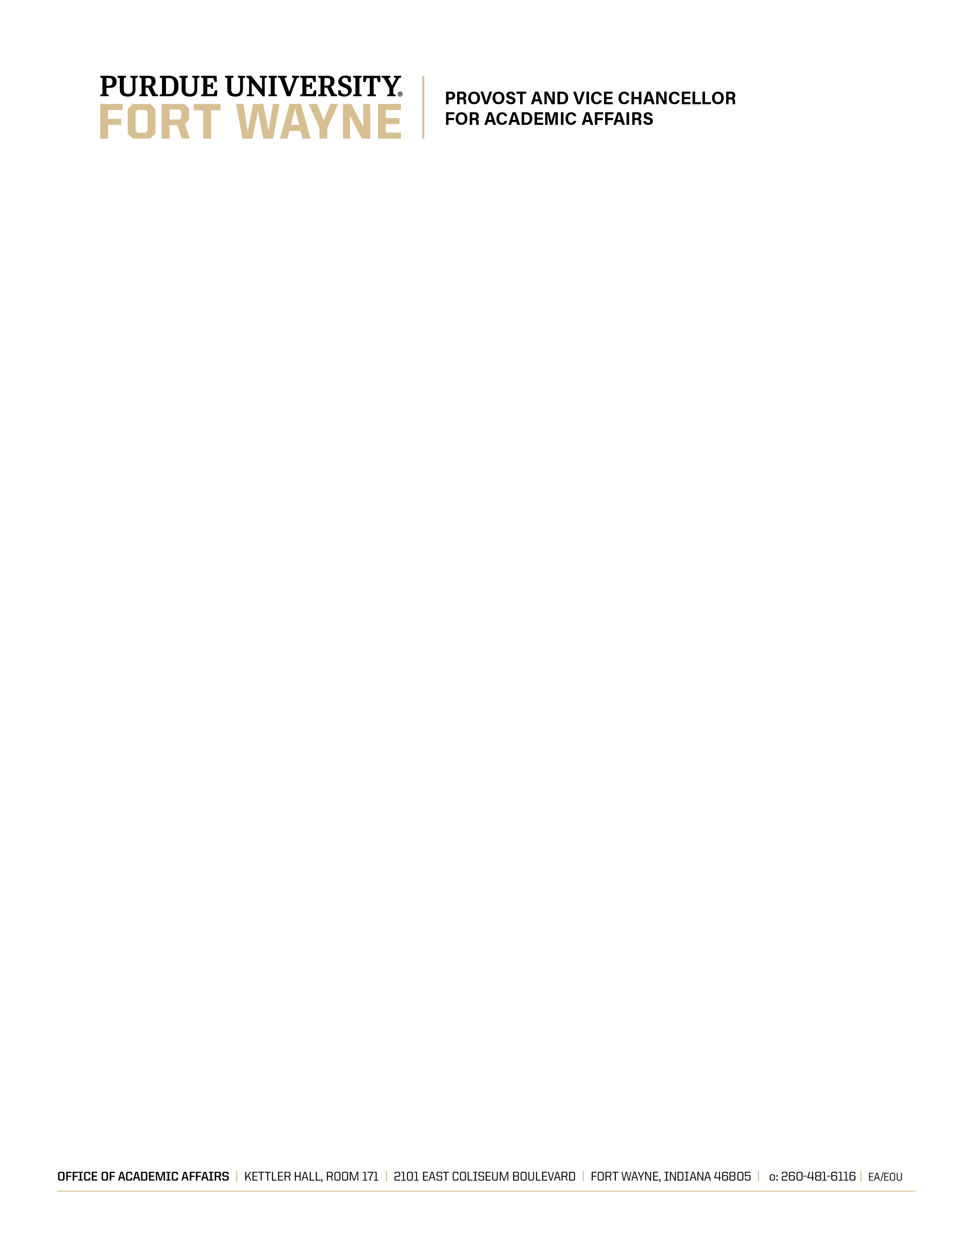

OFFICE OF ACADEMIC AFFAIRS MEMORANDUM 16-2
Revised April 7, 2017
(Supersedes OAA Memo 12-1)
Page 1

In Senate Document SD 93-26, the IPFW Faculty Senate made the Office of Academic Affairs (OAA) responsible for the review of each academic unit (i.e., college, school, division or department) on a recurring schedule. OAA is to develop general guidelines for a process in which the administration, faculty, and staff of each academic unit are to be actively involved in the “organization, conduct, and analysis of the review.” To conclude the process, OAA is to provide feedback to the unit under review and make an annual report on the review process to the Faculty Senate.
This document revises and supersedes OAA Memorandum 12-1 “Guidelines for Review of Academic Programs” in light of subsequent review process experience.
Operating Principles. The review process is based on the following operating principles:
PURPOSE & SCOPE
- The purpose of the review is the enhancement of academic program quality and institutional accountability. An informed assessment of the program provides a basis for planned change.
- Programmatic review will be undertaken at the departmental level. For all other degrees, certificates, minors, and concentrations that are not housed within a specific department, the appropriate administrator (dean or VCAA) will consult with the principal faculty and staff members to determine how the programmatic review will be assigned and undertaken.
CONTENT
- The associated document entitled “Framework for Program Review” provides guidance on information to include in the departmental self-study.
- The self-study report culminates in an analysis of program strengths and weaknesses and recommendations for future improvements. A schedule of improvement activities including milestones and resources needed should be included. The self-study report must be accessible to readers outside the discipline.

OFFICE OF ACADEMIC AFFAIRS MEMORANDUM 16-2
Revised April 7, 2017
(Supersedes OAA Memo 12-1)
Page 2
PROCESS
- Departments are reviewed on a seven-year cycle, unless aligned with a discipline-specific accreditation schedule. The cycle will be circulated by the Director of Assessment (DOA). To avoid the overlapping efforts of program review and accreditation, departments with accredited programs will consult with the VCAA and the Dean as to the nature and the frequency of their self-study.
- The OAA provides support for the review, including a planning workshop for program review committee members, and contributes to the cost of external reviewers. OAA staff can also assist the department by providing access to in-house consultants, reviewing preliminary drafts of the self-study report or providing other assistance as needed.
- The program review is based on a self-study report prepared by the department faculty and staff.
- The self-study primarily will be based on the Departmental Profile provided by Institutional Research, and the annual departmental assessment report, and the annual departmental report. For departments and programs completing their program review prior to Academic Year 2023-24, the 2014-15 and 2015-16 USAP Reports will serve as the first two annual reports. The department will submit the self-study to the dean or his/her designee for comments and feedback. Departments will be given a time frame to make revisions based on the feedback provided, and submit a revised self-study to the dean or his/her designee.
- The department will submit the self-study to the dean or his/her designee for comments and feedback. Departments will be given a time frame to make revisions based on the feedback provided, and submit a revised self-study to the dean or his/her designee.
- A peer review team comprised of at least two individuals, all external to the university, will be appointed by the dean after consultation with the department chair and the OAA.

OFFICE OF ACADEMIC AFFAIRS MEMORANDUM 16-2
Revised April 7, 2017
(Supersedes OAA Memo 12-1)
Page 3
- The peer review team, after being sent the revised self-study, will conduct its review which includes an on-site visit. The team also will submit a report to the department which subsequently will be included as an appendix in the final self-study report.
- The department will prepare a final self-study report after consideration of the feedback from the peer review team. The report is then submitted to the dean and the VCAA.
- The department will meet with the dean and the VCAA to discuss the findings and the plan of action. The results of the meeting will be documented by the dean and/or VCAA and sent to the department chair.
- A suggested timeline for the program review is presented at the end of this document.
OUTCOMES
- The departmental plans will be taken into consideration as part of the annual planning and budgeting processes at the school/college/campus levels. Deans will have responsibility for tracking the process of implementing the recommendations.
- The department will describe progress of their action plan as part of the annual reporting process.
TIME LINE
January: The process is initiated by the Director of Assessment, confirmed by VCAA & dean
February – March: Office of Academic Affairs provides planning workshop
March – April: Department commences self-study by collecting and organizing relevant documents.
April – December: Department conducts self-study and documents findings in a draft self-study report
November: Peer review members are identified and contacted.
December: Department submits the draft self-study report to dean.
OFFICE OF ACADEMIC AFFAIRS MEMORANDUM 16-2
Revised April 7, 2017
(Supersedes OAA Memo 12-1)
Page 4
January: Dean or his/her designee reads self-study and forwards comments to department.
February: Department revises the draft report and addresses all comments. The final self-study report is submitted to the dean.
Early March: External peer review team visits campus to review self-study report.
Early April: Peer review team submits their report to the department.
May: Department submits final self-study report to the dean and VCAA.
Early September: Department meets with dean and VCAA.
Late September: Documentation is provided to the department.

_____________________________
Carl N. Drummond
Vice Chancellor for Academic Affairs

